Lesson 5. Personal Influence and Political Savvy

This page intentionally left blank.

Lesson Objectives

At the end of this lesson, the participants will be able to:

- Recognize the need for and importance of using personal influence.
- Identify the key aspects of political savvy.
- Develop strategies for influencing individuals, groups, and the organization to a specific course of action.

Scope

- Introduction
- Case Study: Findlay City Fiasco
- Personal Influence
- Effective Interpersonal Influence
- Activity: Negotiating Agreement
- Political Savvy
- The Alliance Mindset
- Understanding Your Potential Allies
- Case Study: The Grapevine, Part 2
- Being an Ally to Others
- Developing a “Win-Win” Solution
- Summary and Transition

Methodology

Participants will begin this unit by reviewing a case study in which an emergency manager could use personal influence to improve the city’s emergency management process. Participants will learn about the three types of personal influence and discuss the importance of interpersonal influence. The instructor will present strategies for expanding interpersonal influence, and will then describe skills for negotiating agreement and strategies for undertaking constructive disagreement.

Participants will learn about the importance of political savvy and how to identify what is (and is not) political savvy by using the interest grid. The instructor will present the building blocks of political savvy and review the alliance mindset. The participants will learn strategies for identifying their potential allies, and will then revisit the Grapevine case study from Lesson 4. The instructor will end the lesson by reviewing the strategies for “win-win” solutions in the workplace.

Materials

- PowerPoint visuals 5.1 – 5.29 and a computer display system
- Instructor Guide
- Student Manual

Time Plan

A suggested time plan for this lesson is shown below. More or less time may be required, based on the experience level of the group.

Topic | Time
Introduction | 3 minutes
Case Study: Findlay City Fiasco | 15 minutes
Personal Influence | 5 minutes
Effective Interpersonal Influence | 10 minutes
Activity: Negotiating Agreement | 10 minutes
Political Savvy | 10 minutes
The Alliance Mindset | 10 minutes
Understanding Your Potential Allies | 5 minutes
Case Study: The Grapevine, Part 2 | 15 minutes
Being an Ally to Others | 3 minutes
Developing a “Win-Win” Solution | 2 minutes
Summary and Transition | 2 minutes
Total Time | 1 hours 30 minutes

INTRODUCTION
Visual 5.1

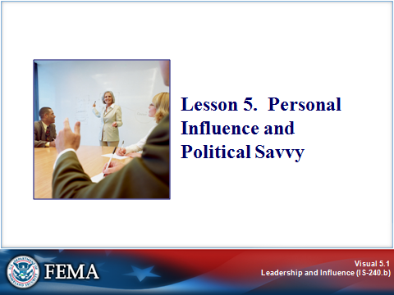
Key Points

In addition to building trust and facilitating change, an effective leader must be able to exert personal influence to achieve emergency management goals. In this lesson, we will focus on the important role of leader as influencer and the skills for effectively influencing others. We will also explore what is involved in being a politically savvy leader.

INTRODUCTION
Visual 5.2

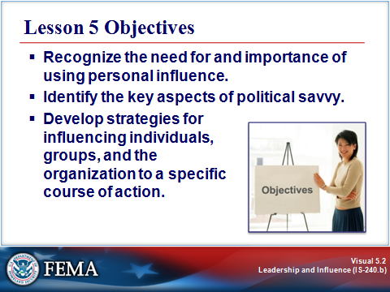
Key Points

After completing this lesson, you should be able to:

- Recognize the need for and importance of using personal influence.
- Identify the key aspects of political savvy.
- Develop strategies for influencing individuals, groups, and the organization to a specific course of action.

INTRODUCTION
Visual 5.3

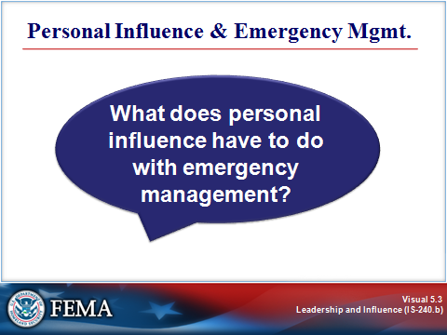
Key Points

What does personal influence have to do with emergency management? To illustrate, let’s begin with a case study.

Read and analyze the following case study. Where do you think personal influence plays a part in the emergency manager’s job?

CASE STUDY: FINDLAY CITY FIASCO
Visual 5.4

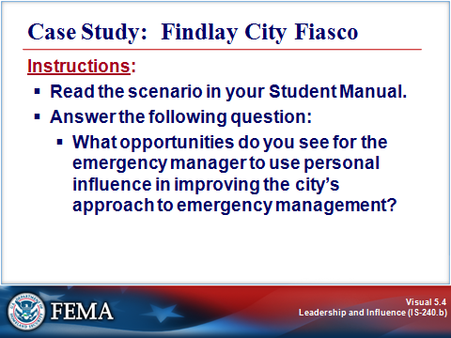
Key Points

Instructor Note: Give the participants 10 minutes to read the case study and answer the question. Facilitate a discussion around their responses to their question.

Instructions:

- Read the scenario below.

- Answer the question that follows.

Scenario:

Jane Canfield is the emergency manager in Findlay City. Last month, the city experienced a disaster. A flash flood inundated the city with water that threatened to overtake the entire downtown area. Because of the massive force of the floodwaters, a levee burst on the outskirts of the city. To compound matters, a hazardous chemical spill closed a major thoroughfare into the city. The spill was releasing toxic fumes into the area and HazMat experts determined that the 100 homes immediately surrounding the accident should be evacuated.

At the time of the disaster, the city had a new mayor who did not yet understand his role in emergency management, so he failed to act quickly to issue an evacuation order. When the delayed evacuation order was issued, the media broadcast it on all TV stations but did not continue the broadcast on the Spanish language station that most Hispanics rely on for their evening news. The outdoor warning system failed in several areas, but people heard the police cars’ sirens and figured that something was wrong. Five people died of respiratory failure as a result of the delay and confusion.

CASE STUDY: FINDLAY CITY FIASCO
Visual 5.4 (Continued)

Scenario: (Continued)

Massive convergence of spectators downtown caused traffic tie-ups that delayed rescue personnel trying to reach people stranded by the floodwaters. The flood caused 14 deaths, 12 of them in a mobile home park. The city council had voted down enforcing the building codes that would have required more reinforcement for mobile homes to protect them against damage.

The emergency manager handled the resource requirements with the assistance of the neighboring jurisdictions, which provided additional fire and rescue support. There was confusion in some agencies about interagency policy and protocol, however, which caused some delays and created an impression of disorganization and lack of cooperation.

Meanwhile, the media sensationalized the story, reported that the city was overwhelmed by the impact, and did nothing to reassure the public.

Looking back on the incident, Canfield realizes there are many ways in which the city can improve its ability to deal with another disaster. She is drafting an action plan that, so far, includes the following items:

- Meet with the mayor to brief him on hazard analysis, the emergency operations plan, authorities and responsibilities, and emergency management statutes and develop a closer working relationship.
- Work with city council, the zoning board, and other appropriate agencies to review existing building code standards and regulations regarding development in hazardous areas.
- Meet with local businesses and trade associations to discuss recovery issues and develop interest in hazard mitigation programs.
- Cultivate local government and community commitment to emergency management.
- Identify organizations and individuals to contact on a regular basis to establish or maintain informal working relationships.
- Identify ways to meet the needs of special populations in the event of a disaster.
- Identify ways to rebuild public trust in Findlay City’s emergency management program.
- Implement public education and awareness campaigns about the hazards that exist in the community and ways to prepare for them.
- Cultivate a positive working relationship with the media to ensure effective early warning systems and unbiased reporting of emergency events.
- Work with those responsible for the outdoor warning system to ensure effective performance in the future.
- Initiate a review of policies and procedures with response groups to ensure future coordination and cooperation.

CASE STUDY: FINDLAY CITY FIASCO
Visual 5.4 (Continued)

Question:

What opportunities do you see for the emergency manager to use personal influence in improving the city’s approach to emergency management?

Instructor Note: Possible responses include:

- Sharing her expertise with the mayor.
- Working with the neighboring jurisdictions to improve coordination.
- Emphasizing the long-term cost saving of mitigation with the city council.
- Initiating activities to rebuild trust within the emergency management program.
- Building strategies for working in partnership with the media.

PERSONAL INFLUENCE
Visual 5.5

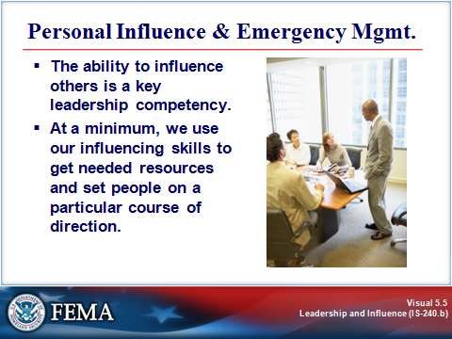
Key Points

The ability to influence others is a key leadership competency. At a minimum, we use our influencing skills to get needed resources and set people on a particular course of direction.

As you probably noticed in the case study, personal influence is absolutely critical in emergency management. Every one of the tasks that the emergency manager outlined in her action plan will require some measure of personal influence, and those tasks cover the entire emergency management spectrum: prevention, preparedness, response, recovery, and mitigation.

The emergency manager will need to exercise her influence in many directions:

- Upward (with the mayor).
- Laterally (with other emergency managers in neighboring jurisdictions, city council, the zoning board, and other agencies).
- Downward (with those responsible for various facets of the emergency management program).
- Outward (with the media, the public, businesses, trade organizations, and specific groups such as the Hispanic community).

PERSONAL INFLUENCE
Visual 5.6

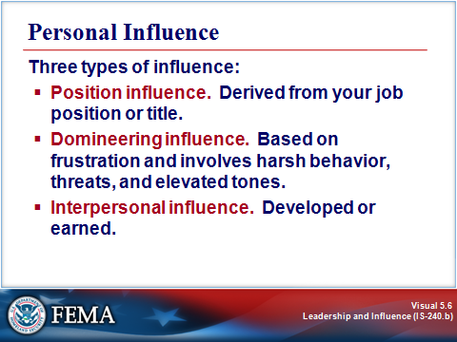
Key Points

When we talk about influencing other people, we generally mean getting them to do something or to think or behave in a certain way.

In the workplace, you have three kinds of influence available to you: position influence, domineering influence, and interpersonal influence.

- Position influence

Position influence is derived from your job position or title. You use your authority to meet your objective. This kind of influence usually results in compliance: employees do what you want because you’re their boss. Position influence can be temporary if you are a project head or in charge of a particular assignment.

The best uses of position influence are when there are strict rules and established procedures, when automatic compliance is required, to recognize and strengthen good performance, and to deal with performance or conduct issues.

- Domineering influence

Domineering influence is usually based on frustration and involves harsh behavior, threats, and elevated tones. The result is often hostility and passive-aggressive behavior. It can destroy working relationships and therefore should only be used when all else fails.

PERSONAL INFLUENCE
Visual 5.6 (Continued)

- Interpersonal influence

Unlike position or domineering influence, interpersonal influence has to be developed or earned. It does not come with a job title or emotion. You build interpersonal influence as you demonstrate your own qualities and skills, such as good listening and reacting skills, a sense of humor, and reliability. Interpersonal influence is based on trust, support, and collaboration. It results in commitment to the task or purpose: people decide that they want to work with you to get the job done.

Interpersonal influence is best used:

- When you have no direct authority over others.
- When “buy-in” is required.
- When creativity and two-way information sharing is required.
- With professionals who expect to be treated with respect and to work collaboratively.
- For teambuilding.
- For responding to change.

Even if you predominantly use one type of influence, you may use all three types with some individuals and groups or in some situations where it is appropriate.

EFFECTIVE INTERPERSONAL INFLUENCE
Visual 5.7

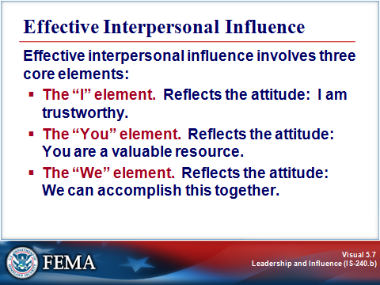
Key Points

Interpersonal influence is something you develop over time, as you build relationships. It is also something that you develop as you gain knowledge and experience in your job. The more you know about your organization, the better equipped you are to influence positively those you need to.

Effective interpersonal influence involves three core elements: “I,” “You,” and “We.” Each element reflects an attitude. When you adopt this attitude, you tend to act in a way that contributes to effective interpersonal influence.

- The “I” element. This element reflects the attitude, “I am a trustworthy ally.” It involves taking actions that demonstrate your personal reliability, competence, and commitment. People learn about you from what you say and how you act. They will determine whether you are trustworthy based on your actions, and they will notice quickly if your actions do not correspond with your words.

Examples of actions that can destroy your credibility include:

- Criticizing people behind their backs.
- “Passing the buck.”
- Repeating confidential information to others.

If people decide that you are not trustworthy, a strong barrier will be created to building an influence relationship.

EFFECTIVE INTERPERSONAL INFLUENCE
Visual 5.7 (Continued)

- The “You” element. This element reflects the attitude, “You are a valuable resource.” Actions that demonstrate this attitude show the other person that you value a working relationship with him or her. Examples include asking for their opinions and ideas and showing appreciation for their contributions.

- The “We” element. This element reflects the attitude, “We can accomplish this together.” The “I” and “We” elements together enable you to build an influence relationship. After you’ve done that, you can use the relationship to work together to solve problems and accomplish your goals (the “We” element).

EFFECTIVE INTERPERSONAL INFLUENCE
Visual 5.8

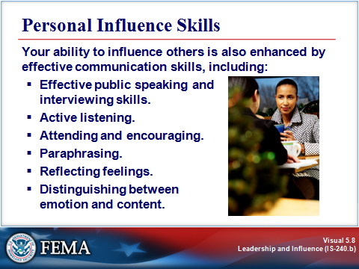
Key Points

You have learned about many personal influence skills in previous lessons. We influence others through our leadership skills, through effective balancing of inquiry and advocacy, through trust-building behaviors, and by being able to communicate change effectively.

Your ability to influence others is also enhanced by effective communication skills, including:

- Effective public speaking and interviewing skills.
- Active listening.
- Attending and encouraging.
- Paraphrasing.
- Reflecting feelings.
- Distinguishing between emotion and content.

To maximize these skills, you may wish to complete the FEMA Independent Study course, Effective Communication (course number IS-242.b).

EFFECTIVE INTERPERSONAL INFLUENCE
Visual 5.9

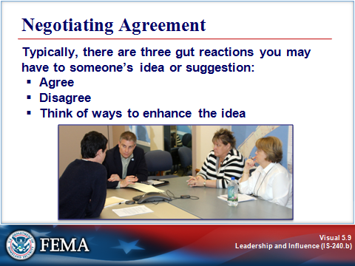
Key Points

Another important skill area in building influence relationships is reacting skills: the ability to react appropriately to another person’s point of view after you understand it. The ability to react effectively is important because influence relationships develop when both parties feel that their ideas are important to the other. Reacting effectively encourages open communication and trust.

Typically, there are three gut reactions you may have to someone’s idea or suggestion:
- Agree
- Disagree
- Think of ways to enhance the idea

No matter what your gut reaction, the important thing is to react to it in a way that is both honest and maintains a positive climate for future communication. There are three skills that will allow you to do this:

Agreeing

If you like the person’s idea, say so. But make sure you state both what you like and why you like it. For example, you might say, “I like your idea of . . . because . . . .” By communicating the value that the idea has for you (i.e., why you like it), you give the person additional reinforcement for offering the idea.

Disagreeing or Enhancing the Idea

The following pages describe how to disagree constructively, and how to build on an idea that someone else offered.

EFFECTIVE INTERPERSONAL INFLUENCE
Visual 5.10

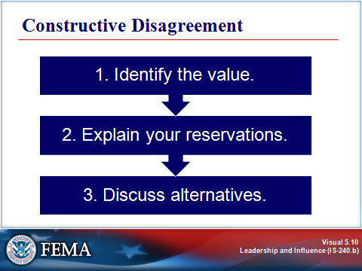
Key Points

When people suggest ideas, they hope that their ideas will be liked. But that isn’t always the case. Sometimes the response is disagreement. People often find it difficult to state their disagreement, however. Either they don’t want to hurt the person’s feelings, or they don’t like to say “no,” or they don’t know how to say “no” diplomatically.

The result is that they sometimes take inappropriate actions, such as postponing giving an answer, going along with an unacceptable idea, or implying that the disagreement stems from someone else (e.g., “I don’t think they will let us do that”).

If disagreement is not handled correctly, the person can become defensive or the possibility of future discussions may be dampened. The self-esteem of the person should be a major concern.

If your reaction is that you see value in the idea but have some reservations (agree with parts and disagree with others), use constructive disagreement. Here’s how:

- Identify the value. For example, you might say, “What I like about your idea is . . . .” If you listened carefully, you’ll understand both the idea and why the person thinks that it’s a good one. Identifying the value in the idea lets the person know that you are listening, which will help the person hear your concerns.

- Explain your reservations. For example, you might say, “What concerns me is . . . ,” or “These are the things that would need to be overcome.” Make sure you’re specific and clear. And avoid the tendency to jump prematurely to your reservations. Express the value first!

EFFECTIVE INTERPERSONAL INFLUENCE
Visual 5.10 (Continued)

- Discuss alternatives. Talk about ways to retain the value while eliminating reservations. The goal is to modify the original idea so that it is acceptable to both of you. The modifications can come from you or from the other person (i.e., either ask for or offer suggestions). If you offer a suggestion, ask the other person for his or her reaction to it. This step keeps the conversation as a two-way dialogue.

EFFECTIVE INTERPERSONAL INFLUENCE
Visual 5.11

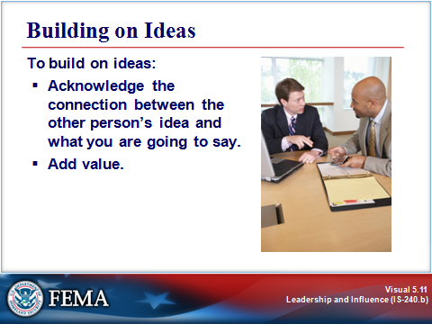
Key Points

When your reaction to someone’s suggestion is that it stimulates your thinking about the idea and ways to enhance it, you have an opportunity to build on ideas to add value to the original idea. This does not mean just offering a new idea of your own. There are two steps in this process.

- Acknowledge the connection. First, acknowledge the connection between the person’s idea and what you are about to say. For example, you might begin, “What you said about . . . .” This lets the person know that you were listening and gives them credit for the initial idea in the building process.

- Add value. Modify the original idea to add value to it (e.g., suggest additional reasons why the idea is a good one or ways to make the idea even better).

ACTIVITY: NEGOTIATING AGREEMENT
Visual 5.12

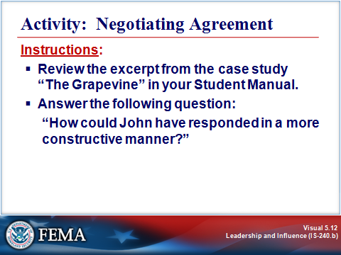
Key Points

Instructor Note: Give the participants 5 minutes to read the scene and think about their answer. Facilitate a discussion around their responses.

Purpose: The purpose of this activity is to examine strategies for negotiating agreement.

Time: 5 minutes

Instructions: Review the scene from the case study “The Grapevine” in Lesson 4. Then answer the question.

Dewayne and Ella reported a conversation to John, and he disagreed with their conclusions about its significance:

So he tells Dewayne and Ella that it’s probably all speculation and that there’s no truth to the rumors. When they continue to question his thinking, he forcefully argues that, if it were true, he would have heard about it long before they did because of how well connected he is with the division’s decision makers. Dewayne and Ella are still skeptical, but they accept his perspective and go back to their tasks.

ACTIVITY: NEGOTIATING AGREEMENT
Visual 5.12 (Continued)

Using the principles of negotiated agreement, how could John have responded in a more constructive manner?

Instructor Note: Use the suggested responses below to facilitate a discussion.

John’s response would have been better if he had:
- Identified the value in their message (appreciation for their sharing the information, acknowledgment of the significance if the message is accurate).
- Expressed his reservations about the reliability of the information.
- Suggested alternatives (people he could talk to, steps he could take).
- Asked for their reactions or suggestions.

While John did some of these things, his response was cut short by his defensiveness, so he did not develop a true two-way dialogue. Rather, he fell back on his position influence instead of using the opportunity to strengthen an influence relationship.

POLITICAL SAVVY
Visual 5.13

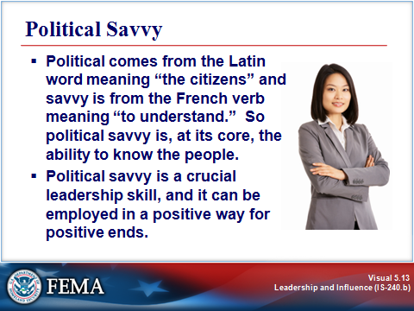
Key Points

There are times when the ability to influence others is not enough, and a good rationale may not be sufficient to sway someone to your point of view. Something is missing. There is another important factor to consider when we are attempting to influence: political savvy.

Political Savvy⎯A Dirty Word?

Many people have strong and contradictory feelings about being political. In fact, strong negative feelings about politics often present the most significant barrier to making the transition from Hired Hand to Leader.

The roots of the term political savvy indicate, however, that our attention should be on others. Political comes from the Latin word meaning “the citizens” and savvy is from the French verb meaning “to understand.” So political savvy is, at its core, the ability to know the people.

Political savvy is a crucial leadership skill, and it can be employed in a positive way for positive ends.

POLITICAL SAVVY
Visual 5.14

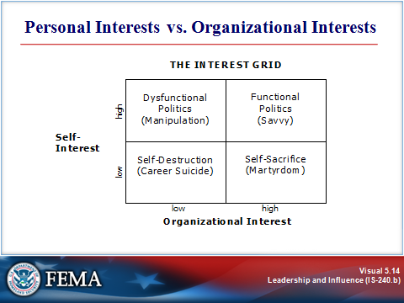
Key Points

Let’s look at a model⎯the Interest Grid⎯that illustrates what political savvy is and what it is not. The Interest Grid contains four quadrants representing high and low levels of self-interest and organizational interest.

As you read about each quadrant in the model, think about a leader you have known (personally or by reputation) who exemplifies this approach.
POLITICAL SAVVY
Visual 5.14 (Continued)

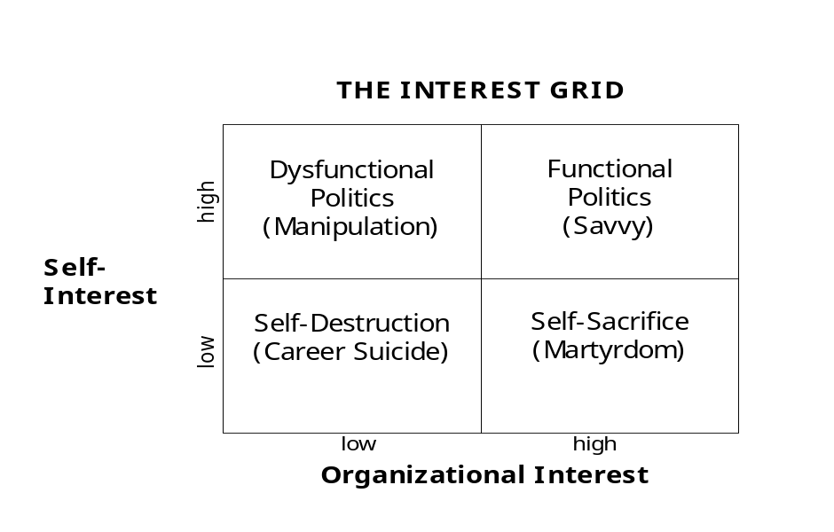

Source: Joel R. DeLuca. Political Savvy: Systematic Approaches to Leadership Behind the Scenes (2nd edition). Berwyn, PA: Evergreen Business Group, 1999.

- Dysfunctional politics: People who engage in manipulation (upper left quadrant) promote their own interests at the expense of the organization.

- Self-destruction: People who take actions that further neither their own interests nor those of the organization (lower left quadrant), are engaging in “career suicide.” This behavior often signals deep discouragement or burnout.

- Self-sacrifice: The lower right quadrant includes people who take actions that further the organization’s interests but that ignore their own. They naturally think about what is right for the organization, and they also know that a reputation for putting aside personal agendas builds credibility. However, when overused, this approach can lead to burnout and martyrdom.

- Political savvy: In the upper right quadrant are people who make decisions that balance their own interests with those of their organization.

POLITICAL SAVVY
Visual 5.15

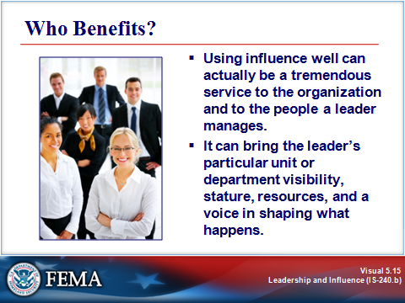
Key Points

Using influence well can actually be a tremendous service to the organization and to the people a leader manages. It can bring the leader’s particular lesson or department visibility, stature, resources, and a voice in shaping what happens.

On the other hand, lacking or misusing political skills can have very serious consequences to yourself, to your unit, and ultimately even to your ability to achieve emergency management goals in the future.

POLITICAL SAVVY
Visual 5.16

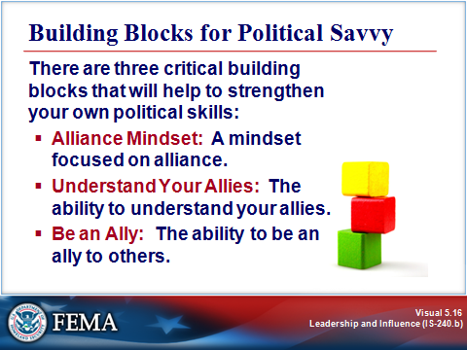
Key Points

There are three critical building blocks that will help to strengthen your own political skills:

- Alliance Mindset: A mindset focused on alliance.
- Understand Your Allies: The ability to understand your allies.
- Be an Ally: The ability to be an ally to others.

THE ALLIANCE MINDSET
Visual 5.17

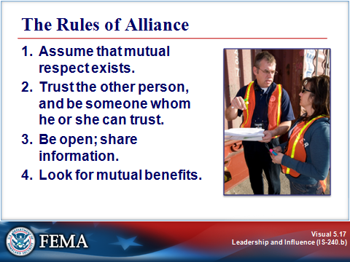
Key Points

Viewing others as potential allies is easier said than done. When trying to influence others, you are most likely to see things from your own perspective and remain focused on your own needs. And the more you care about an issue, the more focused on yourself and your position you tend to become.

Yet failing to see others as allies or partners is often a self-fulfilling prophecy. It increases the likelihood that you will act in ways that may actually heighten others’ resistance to your ideas.

Therefore, perhaps the most crucial building block of political savvy is your mindset. Leaders who are effective are able to view and treat the people around them as partners or potential partners.

The good news is that it is possible to shift from a mindset of seeing people who resist you as adversaries to a mindset of seeing them as potential allies.

There are four basic rules for interacting with people as your allies:

- Assume that mutual respect exists.
- Trust the other person, and be someone whom he or she can trust.
- Be open; share information.
- Look for mutual benefits.

THE ALLIANCE MINDSET
Visual 5.18

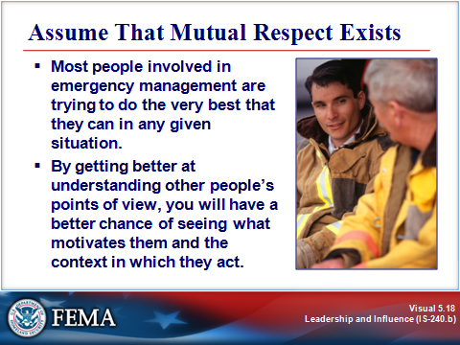
Key Points

Rule 1: Assume That Mutual Respect Exists

Some people will lose your respect by repeatedly taking actions that are boldly self-serving or unethical. But these people are usually the exception, not the rule. More often, you will lose respect for others because of misunderstandings.

Most people involved in emergency management are trying to do the very best that they can in any given situation. By getting better at understanding other people’s points of view, you will have a better chance of seeing what motivates them and the context in which they act.

Rule 1 simply challenges you to let yourself be surprised: to start over, suspend your judgment, and assume that respect exists between you. While it may sound idealistic, consider the alternative: when you assume a position of no respect, barriers go up and options shut down.

THE ALLIANCE MINDSET
Visual 5.19

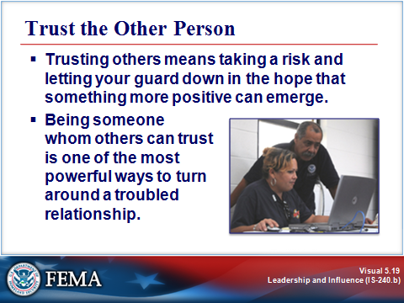
Key Points

Rule 2: Trust the Other Person and Be Someone Whom He or She Can Trust

Trusting others means taking a risk and letting your guard down in the hope that something more positive can emerge. Although sometimes it may not be worth the risk, not taking that risk virtually assures that distrust will mount.

In addition to trusting others, being someone whom others can trust is one of the most powerful ways to turn around a troubled relationship. This, too, involves a “calculated leap of faith,” a willingness to take the first step in building or rebuilding a relationship.

It is this kind of risk-taking that is the hallmark of a person working out of the Leader paradigm, someone who breeds commitment and trust by being committed and trustworthy.

THE ALLIANCE MINDSET
Visual 5.20

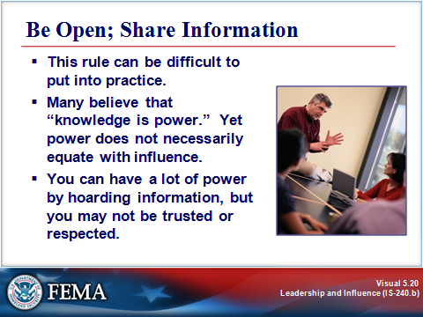
Key Points

Rule 3: Be Open; Share Information

Like the other rules of alliance, this can be a difficult rule to put into practice. Many of us believe that “knowledge is power.” Yet power does not necessarily equate with influence. You can have a lot of power by hoarding information, but you may not be trusted or respected.

Ask yourself: Would you rather be powerful or effective? The traditionally powerful leader might “know it all,” but the person working out of the Leader paradigm who is open and who shares information is more likely to get things done in the long run because of the trust and commitment that he or she builds.

Push past your comfort zone and share more information than you think that you can. See what happens.

THE ALLIANCE MINDSET
Visual 5.21

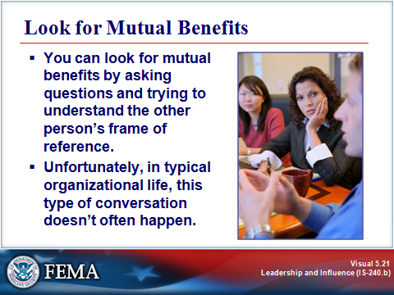
Key Points

Rule 4: Look for Mutual Benefits

You can look for mutual benefits by asking questions and trying to understand the other person’s frame of reference. Unfortunately, in typical organizational life, this type of conversation doesn’t happen as a matter of course. We often fail to take the time to find out about another person’s interests, or we fail to imagine that we might have interests in common.

But these are the prerequisites for finding solutions that are of mutual benefit: taking time to find out about the other person’s interests and looking for common interests.

Remember the advice from Lesson 2: inquiry before advocacy. Make sure you take time to listen before you start selling your own ideas. You may find a lot of common ground on which to build.

Looking for mutual benefit is one of the best ways in which to become someone’s ally, and to allow them to become yours.

Completing the self-reflection on the next page can help you apply the rules of alliance.
Self-Reflection: Applying the Rules of Alliance

Instructions: Think of a current situation in which you and another person are at odds and you want to bring him or her around to your way of thinking. (If no such situation currently exists, think of a past situation.) When you have the situation in mind, answer the following questions.

- Rule 1 says, “Assume that mutual respect exists.” How will you apply this rule? Specifically:

- How does your past history with this person affect your ability to make this assumption?
- What will it take for you to assume that mutual respect exists?
- How can you demonstrate this assumption to the other person?
- Rule 2 says, “Trust the other person and be someone whom he or she can trust.”

- How can you demonstrate your trust and show that you can be trusted?
- How might doing this affect your influence in this situation?
- Are the potential benefits worth the potential risks?
Self-Reflection: Applying the Rules of Alliance (Continued)

Rule 3 says, “Be open; share information.”

- What are the risks and benefits of sharing information in this situation?
- What is a first step that you can take in opening up this relationship?

Risks | Benefits
First step:

- Rule 4 says, “Look for mutual benefits.”

- What potential mutual benefits do you see right now?
- What can you do to learn more about other possible mutual benefits in this situation?

UNDERSTANDING YOUR POTENTIAL ALLIES
Visual 5.22

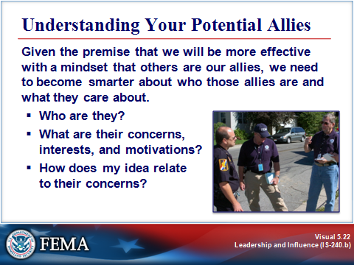
Key Points

Given the premise that we will be more effective with a mindset that others are our allies, we need to become smarter about who those allies are and what they care about.

Another way of looking at the process of understanding your allies is simply this: You want to make it as easy as possible for them to say “Yes” to you. Understanding your allies well enough that you can make it easy for them to say “Yes” requires that you be able to answer three questions:

- Who are they?
- What are their concerns, interests, and motivations?
- How does my idea relate to their concerns?

UNDERSTANDING YOUR POTENTIAL ALLIES
Visual 5.23

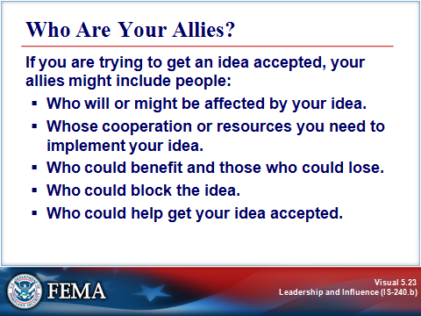
Key Points

First Question: Who Are Your Allies?

If you are trying to get an idea accepted, your allies might include people:

- Who will or might be affected by your idea.
- Whose cooperation or resources you need to implement your idea.
- Who could benefit and those who could lose.
- Who could block the idea.
- Who could help get it accepted.

Allies include not only obvious supporters, but also those whose support you will need but may not have from the outset.

CASE STUDY: THE GRAPEVINE, PART 2
Visual 5.24

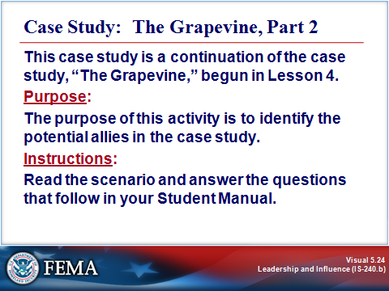
Key Points

Instructor Note: Give the participants 10 minutes to complete this activity. Facilitate a discussion around their responses.

This case study is a continuation of the case study, “The Grapevine,” begun in Lesson 4.

Purpose: The purpose of this activity is to identify the potential allies in the case study.

Time: 10 minutes

Instructions:

Read the scenario on the next page and answer the questions that follow.

CASE STUDY: THE GRAPEVINE, PART 2
Visual 5.24 (Continued)

The Grapevine: Part 2

John and his team leaders are spending the week with their peers from other departments learning about a new training delivery proposal. During Monday’s reception, John approaches a group of managers. In the ensuing conversation he learns the following:

- Not all members of senior management are behind the implementation of the new software.
- The problems with the software that his group identified during the pilot still haven’t been addressed.
- Everyone is grumbling about why the Information Technology (IT) Department didn’t fix the problem or “kill” the program when they had a chance.
- The Personnel Department is in the process of replacing software that had similar functionality after learning that its vendor will no longer support it. Rick and Linda, two highly skilled IT people who used to work for John, are now in Personnel, working for Kim Weston.
- Other departments claim that they’re not going to use the software. They have concluded that it won’t interface with major components of their system and “don’t want to mess with it anymore until the Information Technology (IT) people get in and fix it.” The interface is critical to accomplishing Juanita’s vision of overhauling deployment procedures and efficiency by the end of the year. If these units don’t input the required information at their sites, other employees of the organization won’t be able to access it on the system. In that case, John’s department will bear the brunt of figuring out how to make it work.
- Many are wondering why IT, which recommended the software initially, didn’t address the concerns that were expressed in the pilot and has become neutral on implementation support.

Implementation of the software is a given, either by John or his replacement. His Logistics unit provides a critical function for the organization. And although this choice might not be the perfect software, it’s vital to his department’s mission.

CASE STUDY 5.2: THE GRAPEVINE, PART 2
Visual 5.24 (Continued)

Instructions: Identify John’s potential allies. Use the following questions to guide your analysis:

- Outside of John’s group, whose time and/or resources does Juanita need to implement this initiative?
- Who stands to gain from this initiative?
- Who stands to lose from this initiative?
- Whose approval does this initiative require?

CASE STUDY 5.2: THE GRAPEVINE, PART 2
Visual 5.24 (Continued)

Instructor Note: If not mentioned by the participants, add the following:

- Outside of John’s group, whose time and/or resources does Juanita need to implement this initiative?

- The IT Department. (They will need to fix the interface problems.)
- Other departments’ senior managers, managers, and employees. (They will need to implement changes in their units.)

- Who stands to gain from this initiative?

- All of the employees who are involved with logistics in any way. (Access to logistical information will be streamlined.)
- Everyone in the division who is retained (i.e., all but the 15% who are cut).
- John’s department. (The new system will help it discharge its information gathering and reporting functions, which eases everyone’s workload.)

- Who stands to lose from this initiative?

- The employees who will no longer have jobs.
- The employees in the other departments who will now have to enter logistics-related information.

- Whose approval does this initiative require?

- Senior management
- The IT Department head
- The department managers

UNDERSTANDING YOUR POTENTIAL ALLIES
Visual 5.25

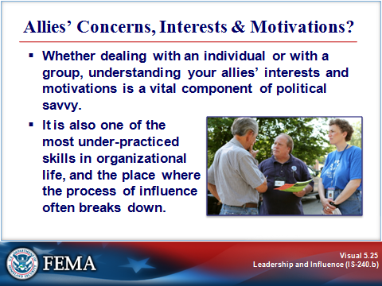
Key Points

Second Question: What Are Your Allies’ Concerns, Interests, and Motivations?

Knowing who your potential allies are is the first step in understanding them. Your next challenge is to figure out how to influence them. One of the best ways to influence others is to understand their world: their pressures, concerns, and perspectives.

A good example of this, on a broad scale, is the need to understand cultural differences within your community. Cultural differences reflect internal beliefs and thought patterns that can cause people to react differently to the same situation. The same may be true of other special groups—whether defined by age, gender, language differences, special needs, or other characteristics. Their own concerns and interests may color how they interact with you.

To a large extent, the misunderstandings that occur involving people from different cultures or special interest groups have nothing to do with what was said—it’s how it was said, what the speaker did while saying it, or even to whom it was said. Clearly, understanding the special interests within your community will enhance the strength of your personal influence.

Whether dealing with an individual or with a group, understanding your allies’ interests and motivations is a vital component of political savvy. It is also one of the most under-practiced skills in organizational life, and the place where the process of influence often breaks down. We frequently become so intent on our own idea that we forget to present it in a way that makes it easier for the other person to accept it.

BEING AN ALLY TO OTHERS
Visual 5.26

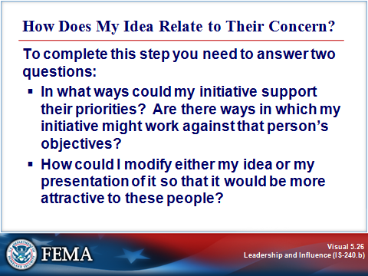
Key Points

Third Question: How Does My Idea Relate to Their Concern?

First, you identified your potential allies in relation to your situation. Next, you focused on trying to understand more about what they care about. The third step is to relate your ideas to those of your allies and to position your idea in a way that makes it easy for these allies to say “Yes.”

To complete this step, you need to answer two sets of questions:

- In what ways could my initiative support their priorities? Are there ways in which my initiative might work against that person’s objectives?
- How could I modify either my idea or my presentation of it so that it would be more attractive to these people?

BEING AN ALLY TO OTHERS
Visual 5.27

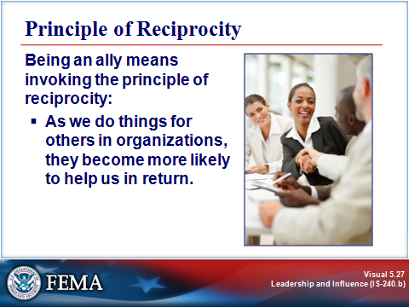
Key Points

We have talked about the importance of having an alliance mindset and understanding your allies. The third building block for political savvy is to be an ally.

Being an ally means invoking the principle of reciprocity:

As we do things for others in organizations, they become more likely to help us in return.

It is important to realize that this is NOT a “scratch my back and I’ll scratch your back” approach. It is also not a tit-for-tat trade where, to get a specific idea through, you promise something in return.

Rather, it means being a friend to others in the organization, because by helping others you will also be helping the organization and helping yourself.

Keep thinking of the metaphor of friendship: You are more willing to support a friend who has been there for you than to support someone who has never shown any particular kindness in the past. The same holds true for organizations. Being an ally means creating a web of good will in which others will be, in turn, more inclined to help you at a time when you need it.

Caution: It will be too late to start being an ally at the point when you need something from someone else. People see right through this as manipulation. Being an ally means taking a day-in and day-out stance of helpfulness, whether you need something today⎯or ever⎯from that person.

The self-reflection on the next page can help you identify strategies for using your personal influence and political savvy.
Self-Reflection: Your Personal Influence and Political Savvy

Situational Influence

- Identify a situation. Think about something that you would like to make happen in your professional situation (e.g., getting an idea adopted, instituting a change, implementing a program or initiative, forging an alliance with another organization or jurisdiction, or solving a problem). What is this change that you’d like to bring into being?
- Who are your potential allies in this situation? Identify:

- Who might be affected by your idea (those who could benefit, those who could lose, and others who would be affected):
- Whose cooperation and/or resources you need:
- Who could block the idea:
- Who could help get it accepted:

Self-Reflection: Your Personal Influence and Political Savvy (Continued)

Instructions: Select the two potentially strongest allies from those you identified earlier, and then answer the following questions about each.

 | Ally #1: ______________________ | Ally #2: _______________________
How could your idea support their priorities?
How could your idea work against them?
How could you modify your plan or your presentation of it to make it more attractive to them?

Self-Reflection: Your Personal Influence and Political Savvy (Continued)

Position Influence

- In your emergency management role, what groups must you influence if you are to be successful? (Think generally⎯not just about the situation that you have been analyzing.)
- For each group identified above, list the factors that will affect how the group can be influenced.
Self-Reflection: Your Personal Influence and Political Savvy (Continued)

Interpersonal Influence

- Identify three strategies for becoming a better ally, over time, to these groups. Your strategies must meet the following criteria:

- Usefulness: They must be actions that would be genuinely useful to others.
- Integrity: They must be actions that are honestly worth doing, whether they ever “buy” you anything in return.

Strategy 1:
Strategy 2:
Strategy 3:

DEVELOPING A WIN-WIN SOLUTION
Visual 5.28

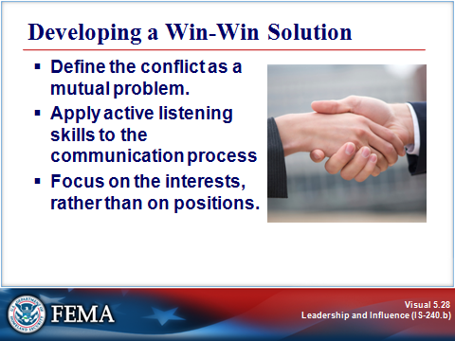
Key Points

Have you ever watched a cat negotiate with a mouse? The cat may allow the mouse some latitude in its actions, but always within the boundaries determined by the cat. Once in a while, the mouse will find a crack in the porch steps through which it escapes to achieve its goals.

In negotiations, do you feel like the cat or the mouse? Is there another way to negotiate?

There are several points to remember when striving for a “win-win” solution:

- Define the conflict as a mutual problem. Be certain that the identification of the conflict includes:
- A clear definition or statement of the issue.
- All of the information that is needed to solve the issue.
- Internal and external factors that affect the issue.
- A blame-free environment for describing the issue.

When people involved can see the situation objectively, they can share in the realization that everyone “owns” the problem and the solution.

- Apply active listening skills to the communication process. Ask yourself: What elements of the issues will active listening find that are important in reaching a “win-win” solution? These elements should include:
- The emotions behind the issue.
- External pressure factors.

- Focus on the interests, rather than on positions. Sometimes, people enter negotiations with position statements rather than with interest statements.

SUMMARY AND TRANSITION
Visual 5.29

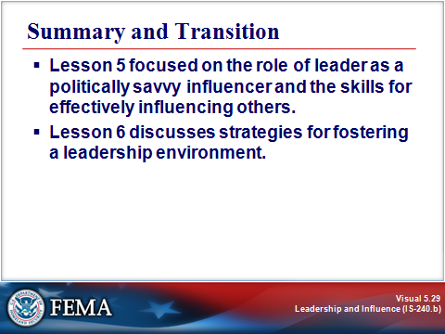
Key Points

Lesson 5 focused on the role of leader as a politically savvy influencer and the skills for effectively influencing others. Lesson 6 discusses strategies for fostering a leadership environment.

For More Information:

Books:

- Political Savvy: Systematic Approaches to Leadership Behind the Scenes. DeLuca, Joel R. LRP Publications, 1999.
- Influence: Science and Practice. Cialdini, Robert B. New York: Allyn & Bacon, 2000.
This page intentionally left blank.

